KEHA Officer and Leadership Training Sessions 2025-2026
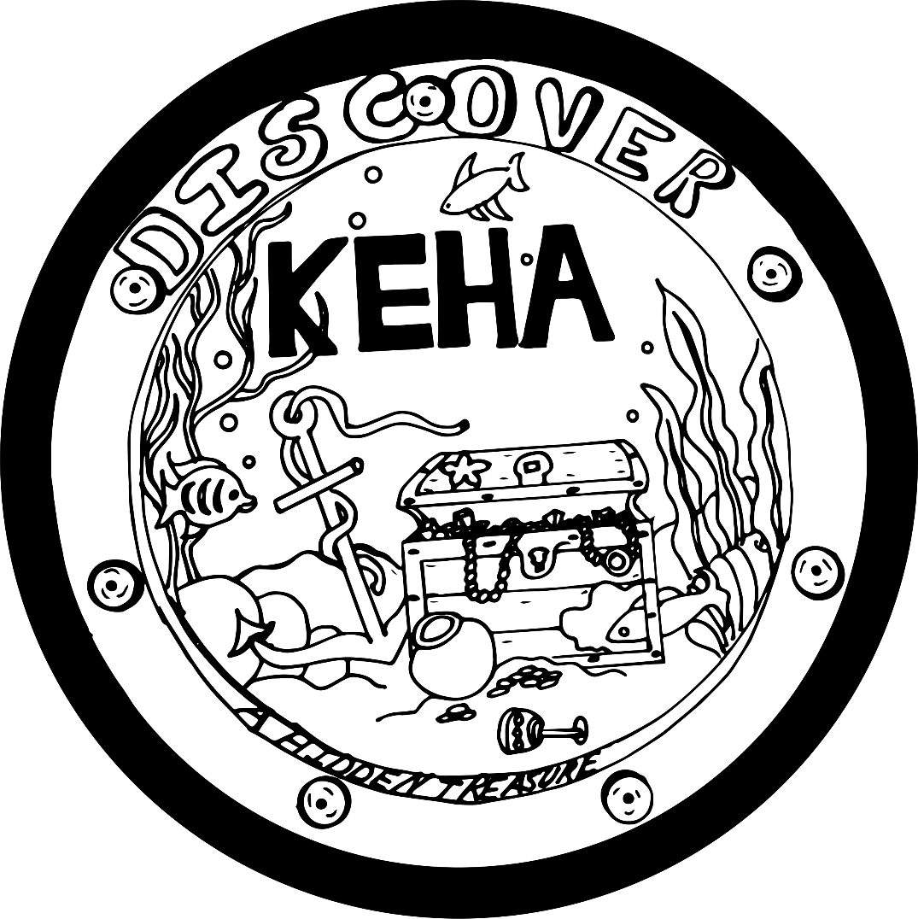
Evaluation Form

Your help is needed in providing vital feedback on the program you have just completed. Please take a moment to complete this survey.

Level of Understanding or Ability
For each of the topics below, in the MIDDLE column, circle the one number that best reflects your level of understanding or ability BEFORE the program. Then, in the RIGHT column, circle the one number that best reflects your level of understanding or ability AFTER the program.
Poor=1, Average =2, Good=3, Excellent=4
 | BEFORE the Program | AFTER the Program
KEHA programming emphases for 2025-2026 | 1 2 3 4 | 1 2 3 4
Results from KEHA 2023-2024 reports | 1 2 3 4 | 1 2 3 4
KEHA membership campaigns and incentives | 1 2 3 4 | 1 2 3 4
Important dates during the KEHA year | 1 2 3 4 | 1 2 3 4

Learning Outcomes
Check whether the following are true as a result of the program.
 | Yes | No
Participating in this lesson improved my leadership skills.
Participating in this lesson increased my confidence in my leadership abilities.

Intentions for Behavior Change
Check whether you plan to change the following behaviors as a result of the program.
 | Yes | No
I plan to share the information from today’s training session with the members of my club.
I will use what I learned today to fulfill a leadership role in my club, county, or area in 2025-2026.

Impact
What is the most significant thing from this program you will apply to your life? (Feel free to list more than one.)

Please list additional comments below or on the back of this page. Thank you for your time.

