
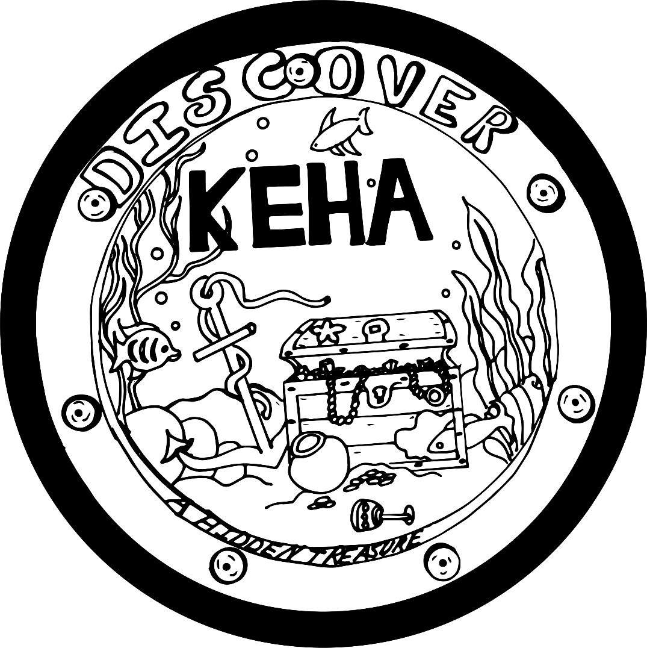

Discover KEHA – A Hidden Treasure
2025-2026

Facilitator’s Guide for
Area, County, and/or Club Officer and Chairperson Training

Training Goal: Provide training and resources for officers and chairpeople at every level of KEHA to perform their duties with knowledge and confidence.

Note for Agents: The major program indicator for officer/chairperson training is Building Leadership Capacity. Possible Impact Indicators are 402.7 Number of people reporting improved leadership skills and 402.14 Number of people reporting increased confidence in their leadership abilities.

Introduction
The Kentucky Extension Homemakers Association (KEHA) is a volunteer organization dedicated to improving the quality of life for families and communities through education, leadership development, and volunteer service. KEHA has been a treasure in the state for 93 years. By helping others “discover KEHA” it won’t remain hidden.

As the KEHA year begins, consider the theme “Discover KEHA – A Hidden Treasure.”
- Do your programs and activities offer a treasure trove of topics and interests? Having a broad variety may spark the interest of more people.
- How can your club or county expand your reach, so that KEHA is not “hidden” in your community? Help new friends discover a valuable organization.
- What can you do to prepare for what your adventure holds – today, tomorrow, and the future?

A collection of resources has been developed incorporating the theme “Discover KEHA – A Hidden Treasure.” These materials are for kickoff meetings and officer training at all levels within the organization. Each item in the collection is described below with suggestions for use. Consider the materials available as you make plans to begin a new KEHA year.

Themed Resources
Graphic
You can use the theme and logo developed for the 2025 KEHA State Meeting throughout the 2025-2026 KEHA year. Find the graphic file on the KEHA website in the “Member Resources” section as part of the 2025 KEHA Officer Training Materials. https://keha.ca.uky.edu/content/theme-materials

Installation Script
An installation ceremony outline and script has been developed incorporating the theme “Discover KEHA – A Hidden Treasure.” Like individual jewels and coins in a treasure chest, officers and chairpeople each add to the wealth of the overall organization. Officers and chairpeople are expected to know the position for which they are being elected and use their skill set to add value. The installation ceremony uses jewels, coins, and treasure chests as symbols to represent the unique skills and energy the officers and chairpeople will bring to fulfill their duties and responsibilities. Clubs, counties, or areas can use this installation ceremony as desired through June 2026.

Roll Call and Thought for the Day
The Roll Call and Thought for the Day document offers 12 options – one per month. This year, the thoughts for the day are related to the monthly themes. They come from a variety of sources. The roll call poses a monthly question for each person to answer as a way to develop deeper connections during meetings.

Icebreaker Activity
Treasure Hunt
Advance preparation: Make copies of the puzzle, enough to have one for every person attending. Cut apart on dotted and wavy lines. Place the eight different pieces around the designated treasure hunt area in a stack (a stack of treasure chests in one place, a stack of pearls in another, etc.). Make it as difficult or easy to find as you prefer. Consider scaling the “hunt” area to accommodate the size of the group. For example, 10 people might search in just one room, but 30 or more people may need several rooms or a larger space. Allow 10-20 minutes for the activity, depending on the size of the group and the difficulty of the search.

Provide instructions: You will be going on a treasure hunt in <note the designated area>. There will be eight cards that you will need to collect, each showing a different item of treasure. When you find an item, collect one of the cards from the stack. Once you have collected your eight pieces of treasure, bring them back to your seat and assemble them like a puzzle. A hidden question will be revealed! When you finish, think about your answer, as we will share with the group at the end.

The question revealed after the puzzle is assembled is: What special treasure or talent do you bring to KEHA? Have each member of the group share something special about themselves.

Presentations and Handouts
A “Discover KEHA – A Hidden Treasure” overview presentation has been developed for use at kickoff meetings or leadership training. Adapt the presentation to fit your agenda. You can print the slides and use them as handout materials to supplement a presentation or instead of displaying the slides on-screen. The presentation has 32 slides. An outline of the presentation content follows.
- Slides 2-5 – General information about the KEHA mission and the three-part focus on education, leadership, and service
- Slide 6 – Theme for 2025-2026
- Slide 7 – KEHA president’s focus for 2025-2028
- Slide 8 – 2026 KEHA Leadership Academy
- Slide 9 - Membership drive and challenge information
- Slide 10 – Points to consider when developing a club or county program of work
- Slides 11-18 – One slide per educational chairperson showcasing the program focus for 2025-2026 and beyond
- Slides 19-23 – Report highlights from 2023-2024 and basic information about the use of reports
- Slides 24-30 – Dates to remember for 2025-2026
- Slides 31-32 – Concluding slides with information about staying informed regarding KEHA activities, the KEHA Facebook page, and a note of encouragement for all members

A second PowerPoint formatted using another “Discover KEHA – A Hidden Treasure” template gives information about roles and responsibilities. You can edit the two presentations or combine them to suit your needs.

Wrap-Up Activity
Time, Treasure, and Talent
Activity instructions:
This will be a breakout activity to discuss the importance of Time, Treasure, and Talent to the KEHA organization. Go around the room and have everyone count off by three. All the ones will get together to discuss Time, all the twos will discuss Treasure, and all the threes will discuss Talent. As your group discusses, brainstorm several new ways KEHA can increase the resource you were assigned. Have someone take notes and appoint someone to share your group’s ideas back with the whole group. Hopefully, there will be some new ideas you can implement this year!

2025-2026 KEHA Dates to Remember
This document gives general and year-specific dates for the KEHA deadlines, activities, and events.

Evaluation
An end-of-program evaluation form is available for use at the conclusion of the training session. This evaluation also is available as a Qualtrics survey at https://bit.ly/KEHAtraining25 or using the QR code below. The “county” field in the online survey is required to enable the data to be sorted and returned to each county if requested. For help with evaluation results, contact KEHA Advisor Kelly May at k.may@uky.edu.


Written by Kelly May, M.S., KEHA State Advisor and Senior Extension Associate for Family Finance and Resource Management, University of Kentucky Family and Consumer Sciences Extension, and Barbara Breutinger, B.S., Family Financial Counseling student interning with Family and Consumer Sciences. June 2025

