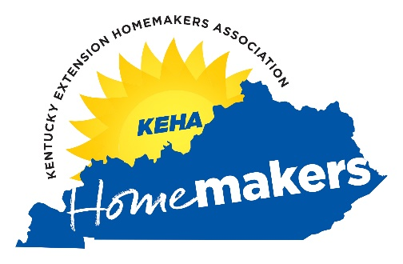
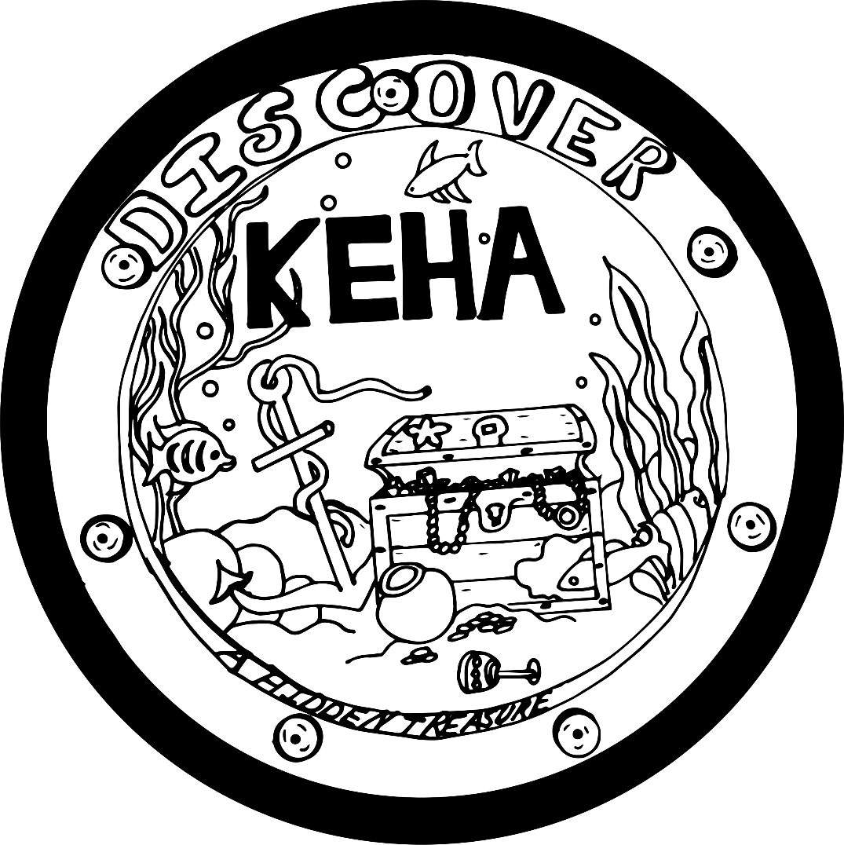
Roll Call &
Thought for the Day
for KEHA Monthly Club Meetings

Discover KEHA – A Hidden Treasure
2025-2026

July 2025
Thought for the Day: “Barbecue may not be the road to world peace, but it’s a start.” – Anthony Bourdain
Roll Call: July is National Grilling Month. What is your favorite thing to cook on the barbeque?

August 2025
Thought for the Day: “Some things you have to do every day. Eating seven apples on Saturday night instead of one a day just isn’t going to get the job done.” – Jim Rohn
Roll Call: August is National Wellness Month. What is your favorite healthy food?

September 2025
Thought for the Day: “The heat of autumn is different from the heat of summer. One ripens apples, the other turns them to cider.” – Jane Hirshfield
Roll Call: September is the beginning of Autumn. What is your favorite activity in the Fall?

October 2025
Thought for the Day: “Vegetables are a must on a diet. I suggest carrot cake, zucchini bread, and pumpkin pie.” – Jim Davis
Roll Call: October is National Dessert Month. What is your favorite dessert?

November 2025
Thought for the Day: “Feeling gratitude and not expressing it is like wrapping a present and not giving it.” – William Arthur Ward
Roll Call: November is National Gratitude Month. What are you grateful for today?

December 2025
Thought for the Day: “One kind word can warm three winter months.” – Japanese proverb
Roll Call: December is the beginning of Winter. What is one thing you enjoy doing in the Winter?

January 2026
Thought for the Day: “I find television very educating. Every time somebody turns on the set, I go into the other room and read a book.” – Groucho Marx
Roll Call: January is National Hobby Month. What is your favorite hobby?

February 2026
Thought for the Day: “The difference between involvement and commitment is like ham and eggs. The chicken is involved; the pig is committed.” – Martina Navratilova
Roll Call: February is National Hot Breakfast Month. What is your favorite hot breakfast?

March 2026
Thought for the Day: “Don’t wait for someone to bring you flowers. Plant your own garden and decorate your own soul.” – Luther Burbank
Roll Call: Spring begins in March. What is your favorite thing about Spring?

April 2026
Thought for the Day: "Money is a terrible master but an excellent servant.” – P.T. Barnum
Roll Call: April is Financial Literacy Month. What is the best tip you ever learned about money?

May 2026
Thought for the Day: “We don’t grow older. We grow riper.” – Pablo Picasso
Roll Call: May is National Strawberry Month. What is your favorite way to eat strawberries?

June 2026
Thought for the Day: “Candy is the answer. Who cares what the question is?” – Unknown
Roll Call: June is National Candy Month. What is your favorite candy?

Written by Barbara Breutinger, B.S., Family Financial Counseling student interning with Family and Consumer Sciences. June 2025

